HR Service Requests

Project: AI Assistant for HR
Task: Research HR Service Requests
Role: Dev
Sprint 1-Week 1

Deliverable: HR service request process diagram, resourcing-cost analysis, 2–3 real AI examples, and a risk/ethics assessment.
Prepared by: Minh Quang Tran (s4089848)

Purpose
Imagine an employee who just moved house. Updating their address is a two-minute task on paper — but in practice, that email sits in a shared inbox until someone opens it, gets classified by hand, is forwarded to payroll, and only then actually gets changed. The gap between what the task actually requires and how long it takes today is what this document is about.
- Map the gap in process terms — where staff time is spent, and how much of it is avoidable.
- With real deployed examples, that AI is already closing this exact gap elsewhere — used here as evidence of what's realistic, not as a proposed solution yet.
- And because HR often deals with sensitive/critical data the risks and ethical guardrails that any solution would need to earn employees' trust, not just save time.

Current-State Process
Here is a simple example of how a HR Service Request workflow would look like:
Step | What happens | Who | Resourcing cost
1 | Employee sends a request | Employee | Trigger only — no cost yet
2 | HR reception receives it | HR | HR time: opening and logging
3 | Catalogs and categorizes the request | HR | HR time: manual classification
4 | Routed to the specialist who can resolve it | HR | HR time: manual lookup and handoff
5a | Specialist contacts employee to resolve it | Specialist | Specialist + employee time, back-and-forth
5b | Specialist resolves it directly | Specialist | Specialist time only
6 | Specialist confirms the request is resolved | Specialist | Specialist time: reporting back
7 | HR receives confirmation of completion | HR | HR time: manual close-out
8 | Request closed; employee notified | HR | HR time: final reply

The same process, in flow chart:
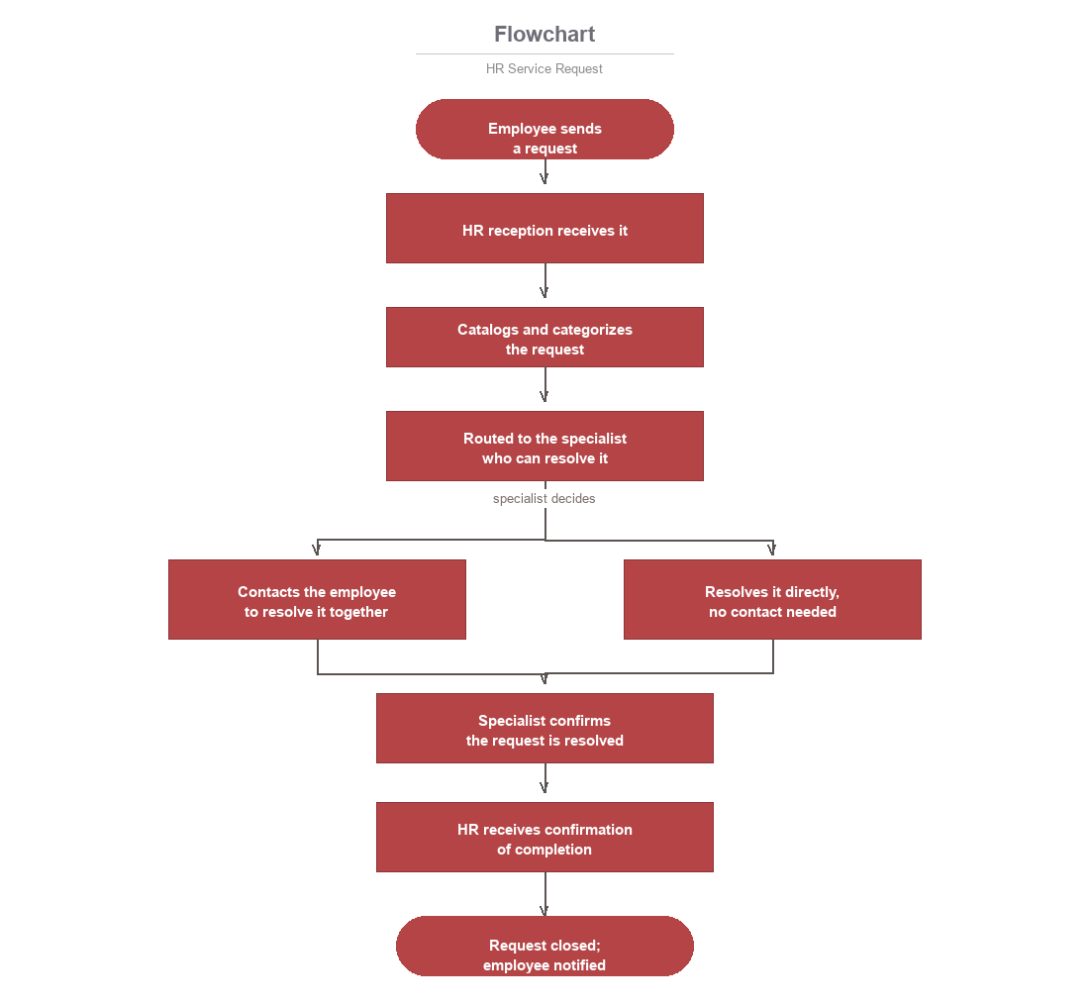
Follow that same address change through the diagram above: it starts as one email, but by step 8 it has passed through four different pairs of hands — reception, a classifier, a specialist, and finally a reply — and at no point along the way could that employee have checked where it actually was.

Pain Point
Bottleneck | What's happening | Resourcing impact
No shared queue | A request only moves when someone checks the inbox | HR/specialist idle-wait time, no SLA
Manual sorting | Every request, however trivial, is read and classified by a person | HR time spent on every request, regardless of complexity
Manual handoff | Forwarding is the only routing mechanism there is | HR time, plus delay risk
Re-typing the same data | An address or bank detail is often entered twice, in two systems | Doubles specialist time for a single change
No status to check | Nothing tells an employee whether a request is in progress | Employee follow-ups generate extra HR time
No coverage when someone's out | A stuck request just waits for the right person to return | Delayed resolution, no cost-avoidance plan
Nothing measures any of this | No timestamps or queue, so no one can say how long requests take | No baseline to size the resourcing case against

Put a number on it: if an HR team handles even 50 of these requests a week, and each one costs just 10 minutes of triage before anyone does the actual resolving, that's more than eight hours — over a full working day — spent every week deciding who should own a request, before any of it is actually resolved. None of that eight hours is the task itself; all of it is the process around the task.
Three underlying causes sit behind that number:
- Nothing routes itself — HR time is spent on manual triage at every volume, regardless of complexity.
- Nothing is written once — specialist time effectively doubles on any request touching two systems.
- Nothing is visible — the follow-up messages a status update would remove instead become additional HR time.

Proven AI Impact from Elsewhere
Not whether AI could help — whether it already does, at real organizations, and what that's worth in hours and dollars rather than in theory.

IBM AskHR
IBM runs its own internal assistant, AskHR, across more than 80 HR tasks — the same category of small, recurring request described above. It now handles roughly 2.1 million employee conversations a year and resolves 94% of them without a person reaching in, which IBM ties to a 40% drop in HR operating costs since rollout. Put concretely: one internal department alone saved around 12,000 hours in a single quarter — roughly the equivalent of six people working full-time for three months, absorbed without adding a single new hire.
- Relevant problem:
manual sorting and handoff (steps 3–4 above).
- Resourcing value:
HR time currently spent triaging and routing becomes reallocatable to higher-value work.

Leena AI
Leena AI answers policy questions, manages leave balances, and handles document requests like payslips, escalating anything it can't resolve. The difference worth noting: its self-service rate isn't just a reported result, it's a contractual commitment — a 70% self-service ratio, guaranteed. In practice, that means roughly seven in every ten requests never touch HR or specialist time at all.
- Relevant problem:
repeated low-stakes questions and document requests.
- Resourcing value:
a measured ceiling on realistic effort reduction, not a marketing estimate.

Answering vs. acting
The more useful split in the research isn't between products — it's between AI that answers a question and AI that actually does something. An assistant that tells an employee their leave balance hasn't done anything a document couldn't have done; one that updates a bank detail, and confirms it, has replaced a step a person used to do. Neobrain's research puts the automatable share of repetitive HR admin at roughly 80%, but most of that is the answer-and-route half — actually changing someone's data (steps 5a/5b above) is the smaller, harder slice, and it's the one the brief is actually asking for: “handle it automatically, or route it to the right person” means the AI has to do something, not just explain something.
- Relevant problem:
requests needing an actual system change, not just an answer.
- Resourcing value:
removing specialist actioning time is worth more than removing HR triage time — and is harder, and riskier, to build.

Risk Assessment and Ethical Governance
Risk area: Undetected incorrect modification
What could go wrong: The AI misreads a request or acts on incomplete information and changes a critical field — a bank account, an address, a pay rate — to the wrong value. It still returns a normal-looking confirmation, so the error is indistinguishable from a correct update at the moment it happens.
Why it matters: Nobody catches it until the consequence shows up somewhere else — a payslip goes to the wrong account, a document is mailed to the wrong address — often well after the fact, when the original request and the mistake are hard to reconstruct or reverse.
What responsible use looks like: A verification step before any critical-field change is committed (e.g. echoing the new value back to the employee for confirmation or flagging any change that differs sharply from the existing record), plus a full audit log of what changed, when, and from what value to what value.
Risk area: Unclear accountability when it does go wrong
What could go wrong: Once an incorrect change is found, it's not obvious whose responsibility it is — the employee who submitted an ambiguous request, the AI that misinterpreted it, or whoever built and approved the system to act autonomously in the first place.
Why it matters: Without a clear answer, mistakes take longer to fix (no one owns the fix), and there's no accountable party to improve the system afterward — the same failure can recur.
What responsible use looks like: Every category of AI-actioned change has a named human owner responsible for it, regardless of how rarely they need to intervene — the AI acting alone is never the final word on a critical-data change without someone accountable for the outcome.

References — APA 7th edition
- IBM. (2024, July 17). Artificial Intelligence for Human Resources | IBM. Ibm.Com. https://www.ibm.com/think/topics/ai-in-hr
- IBM. (2025, March 28). AI agents in human resources. Ibm.Com. https://www.ibm.com/think/topics/ai-agents-in-human-resources
- IBM. (n.d.). Transforming HR support with agentic AI: IBM AskHR case study. Ibm.Com. https://www.ibm.com/case-studies/ibm-askhr
- AIHR. (n.d.). AI HR Assistant: What It Is and How to Use It. AIHR. https://www.aihr.com/blog/ai-hr-assistant/
- Bessemer Venture Partners. (n.d.). Leena AI: From HR chatbot to the agentic enterprise. Bvp.Com. https://www.bvp.com/atlas/leena-ai-from-hr-chatbot-to-the-agentic-enterprise
- Neobrain. (n.d.). 7 AI use cases for HR teams. Neobrain.io. https://www.neobrain.io/en/blog/ai-uses-cases-hr-teams
- Australian HR Institute. (n.d.). 7 questions to help HR navigate the new AI governance frontier. Ahri.Com.au. https://www.ahri.com.au/articles/7-questions-to-help-hr-navigate-the-new-ai-governance-frontier

